Experiment No. 7

Title:
Multimedia Integration in the GrocerySpot App

Objective:
To enhance user engagement and experience by integrating multimedia features into the GrocerySpot app.

Theory:

Incorporate multimedia features such as image uploading, audio playback, and video demonstrations:

Image Uploading:

GrocerySpot introduces a feature allowing users to upload images of their grocery purchases directly within the app.
Users can capture photos of their products using their device's camera or select images from their drive.
Image uploading enhances user engagement by enabling users to visually catalog their purchases, share their shopping experiences, and provide feedback on product quality.

Video Recording:

In addition to image uploading, GrocerySpot incorporates video recording functionality to enrich the user experience further.
Users can record short videos showcasing the fault in the product that was delivered.

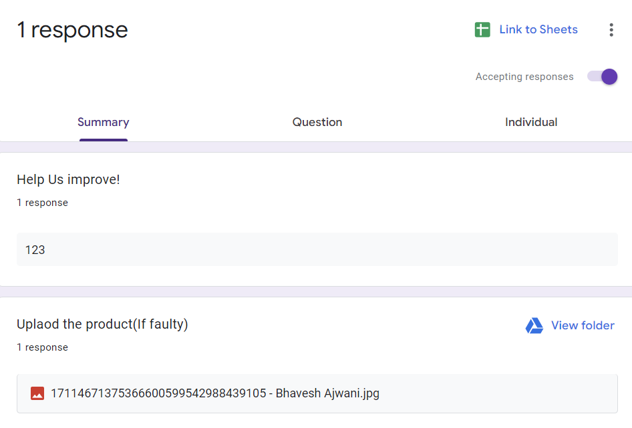

Implement a QR code scanner:
Adding a QR code scanner to GrocerySpot lets users quickly and securely pay for their groceries by scanning QR codes at checkout. When users scan a QR code, they're taken to Google Pay to finish the payment safely. This makes shopping easier and faster. It also helps GrocerySpot understand how people shop, so they can make the experience even better in the future.


Conclusion:
By letting users upload images and record videos of their grocery purchases, GrocerySpot makes shopping more interactive and helpful. Users can share what they bought or if there's something wrong with a product, they can show it in a video. This helps GrocerySpot improve its service and make customers happier. Also, adding a QR code scanner for payments makes buying groceries easier and faster. You just scan a code and pay with Google Pay. These changes make GrocerySpot better for everyone, making shopping more fun and convenient while helping the app learn how to serve users even better in the future.

